REPORT:
COST Action TD1002 / STSM 14053
Title: Combined AFM and TERS measurements of biological membranes

Recipient: Ludovic ROUSSILLE

GROUP: Simon SCHEURING / U1006 INSERM / Aix-Marseille Université, France
HOST: Renato ZENOBI / Department of Chemistry, ETH Zurich, Switzerland

A major goal of near-field optical microscopy has always been to combine the high spatial resolution of Scanning Probe Microscopy (SPM) with the capability of spectroscopy for acquiring chemical information. Noble-metal nanostructures are known to give a good enhancement in the Raman scattering observed from molecules in close proximity (Surface Enhanced Raman Spectrometry – SERS ¹). In Tip-Enhanced Raman Spectrometry (TERS) we use the SPM tip apex in this way. While the spatial resolution of conventional Raman spectroscopy is diffraction-limited (0.5 µm), TERS can reach a resolution below 1 nm ².

I spent 2 months at the ETH Zurich in the laboratory of Professor Renato Zenobi. My work there was split into two periods. During the first month, I gained hands-on experience on the homemade AFM-TERS instrument (a combination of a Bruker, Catalyst AFM, a Kaiser, Holospec Raman spectrograph and an Olympus IX70 inverted microscope). I also was involved in a tip testing study (work still in progress).
The AFM-TERS tips used in the group are silver-coated commercial AFM tips (Olympus OMCL-RC800PSA-W). The silver coating is prone to oxidation and mechanical degradation, limiting their lifetime to a few hours. The aim of these experiments is to test whether the lifetime of the TERS probes can be increased by adding a protection layer. We tested three kinds of tips: unprotected, protected by alumina deposited by Atomic Layer Deposition (ALD) and by silica (deposited by a chemical method). To check if the TERS tips were still enhancing the Raman signal after two to three weeks, we performed Raman measurements on thin films of Brilliant Cresyl Blue (BCB) prepared by spin-coating on glass coverslips, with tip in contact (TERS measurement) and tip out of contact of the surface (conventional Raman) (Figure 1). The ratio between the areas underneath the Raman signal peak provides a measure for the contrast under the different conditions, which is a good measure of the enhancement factor of TERS. Most of the tips (70%) still display good contrast values (20 to 100) after two to three weeks. This is a very good improvement over non-protected tips, which last only a few hours. A more comprehensive study on the lifetime of protected tips will start after the reconstruction of the AFM-TERS setup (see below).

a) with Al₂O₃ protection layer | b) with SiO₂ protection layer
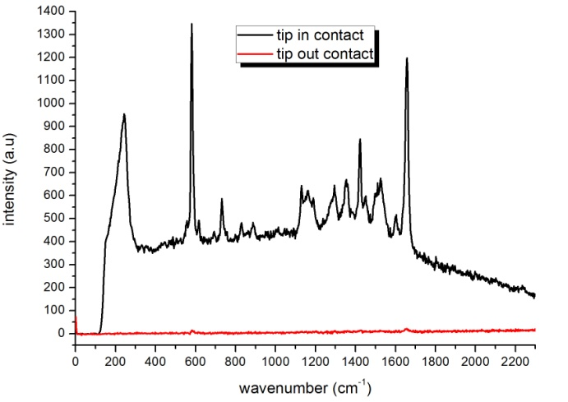 | 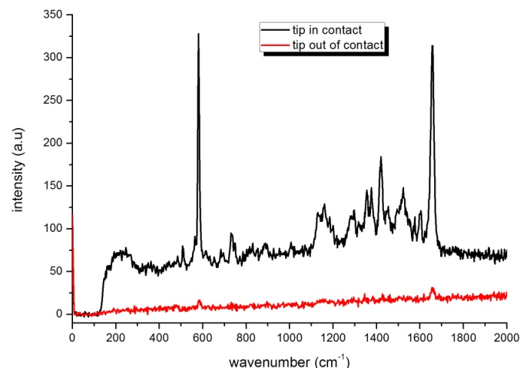
Figure 1: Brilliant Cresyl Blue TERS (tip in contact, black line) and conventional Raman (tip retracted, red line) spectra, with a silver-coated AFM tip protected with a) Al₂O₃ and with b) SiO₂ (acquisition time: 5s and laser power 50 μW).

The reference sample used for this study, BCB, has several drawbacks. BCB photobleaches, degrades easily under the laser beam and produces carbonaceous contaminants giving numerous and strong Raman bands. Furthermore BCB is prone to be picked up by the tip and remain on it, rendering it useless for further measurements. As shown on Figure 2, when performing a TERS experiment on a clean coverslip with the tip used on BCB, we clearly identify BCB peaks. The tip has been contaminated by BCB and cannot be used for further measurements.
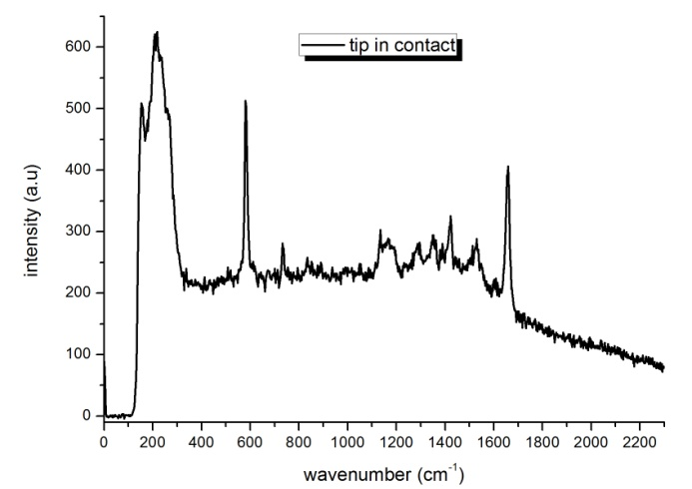
Figure 2: Raman spectra with tip in contact on empty glass after measurements done on BCB sample.

We exposed the tip during 45 min to UV/O₃ radiation to clean it. No trace of BCB has been detected after this treatment but the TERS enhancement was found weakened (tested on BCB sample).

There is a strong need for a TERS reference sample that does not contaminate the tip. Inorganic thin films like 40 nm diamond membranes are good candidates. We consistently found that the Raman signal of diamond membranes was only slightly enhanced (Figure 3a). In a control experiment, using the same tip on a BCB thin-film, we observed a higher contrast between tip in contact and tip out of contact spectra (Figure 3b), indicating that diamond membranes are were not a suitable benchmark sample. Other samples are currently under study.

a) | b)
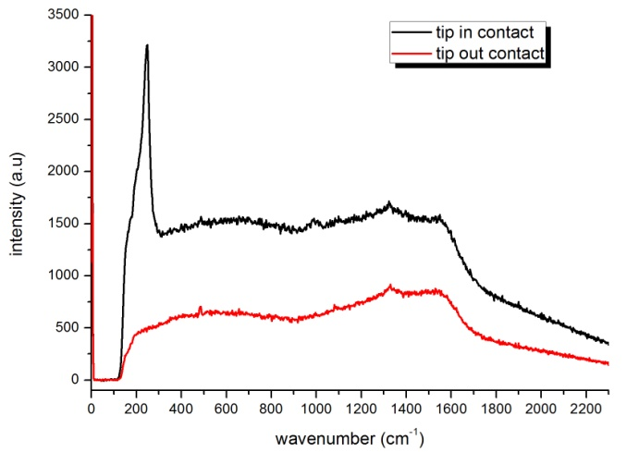 | 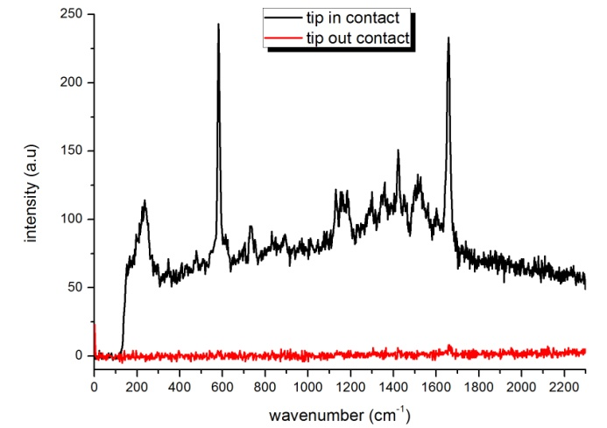
Figure 3: enhancement of Raman signal when tip is in contact (black line) or out of contact (red line) with the surface: a) on Diamond Membrane (acquisition time: 10x10s and laser power 100%) and b) on BCB (acquisition time: 5s and laser power 50%) with the same tip.

The second month was focused on setting up the new Raman spectrometer (InVia, Renishaw). The setup uses two lasers (532 nm and 633 nm) and two CCDs (Renishaw and Andor). All components have been aligned with the inverted microscope (IX70, from Olympus) (Figure 4).

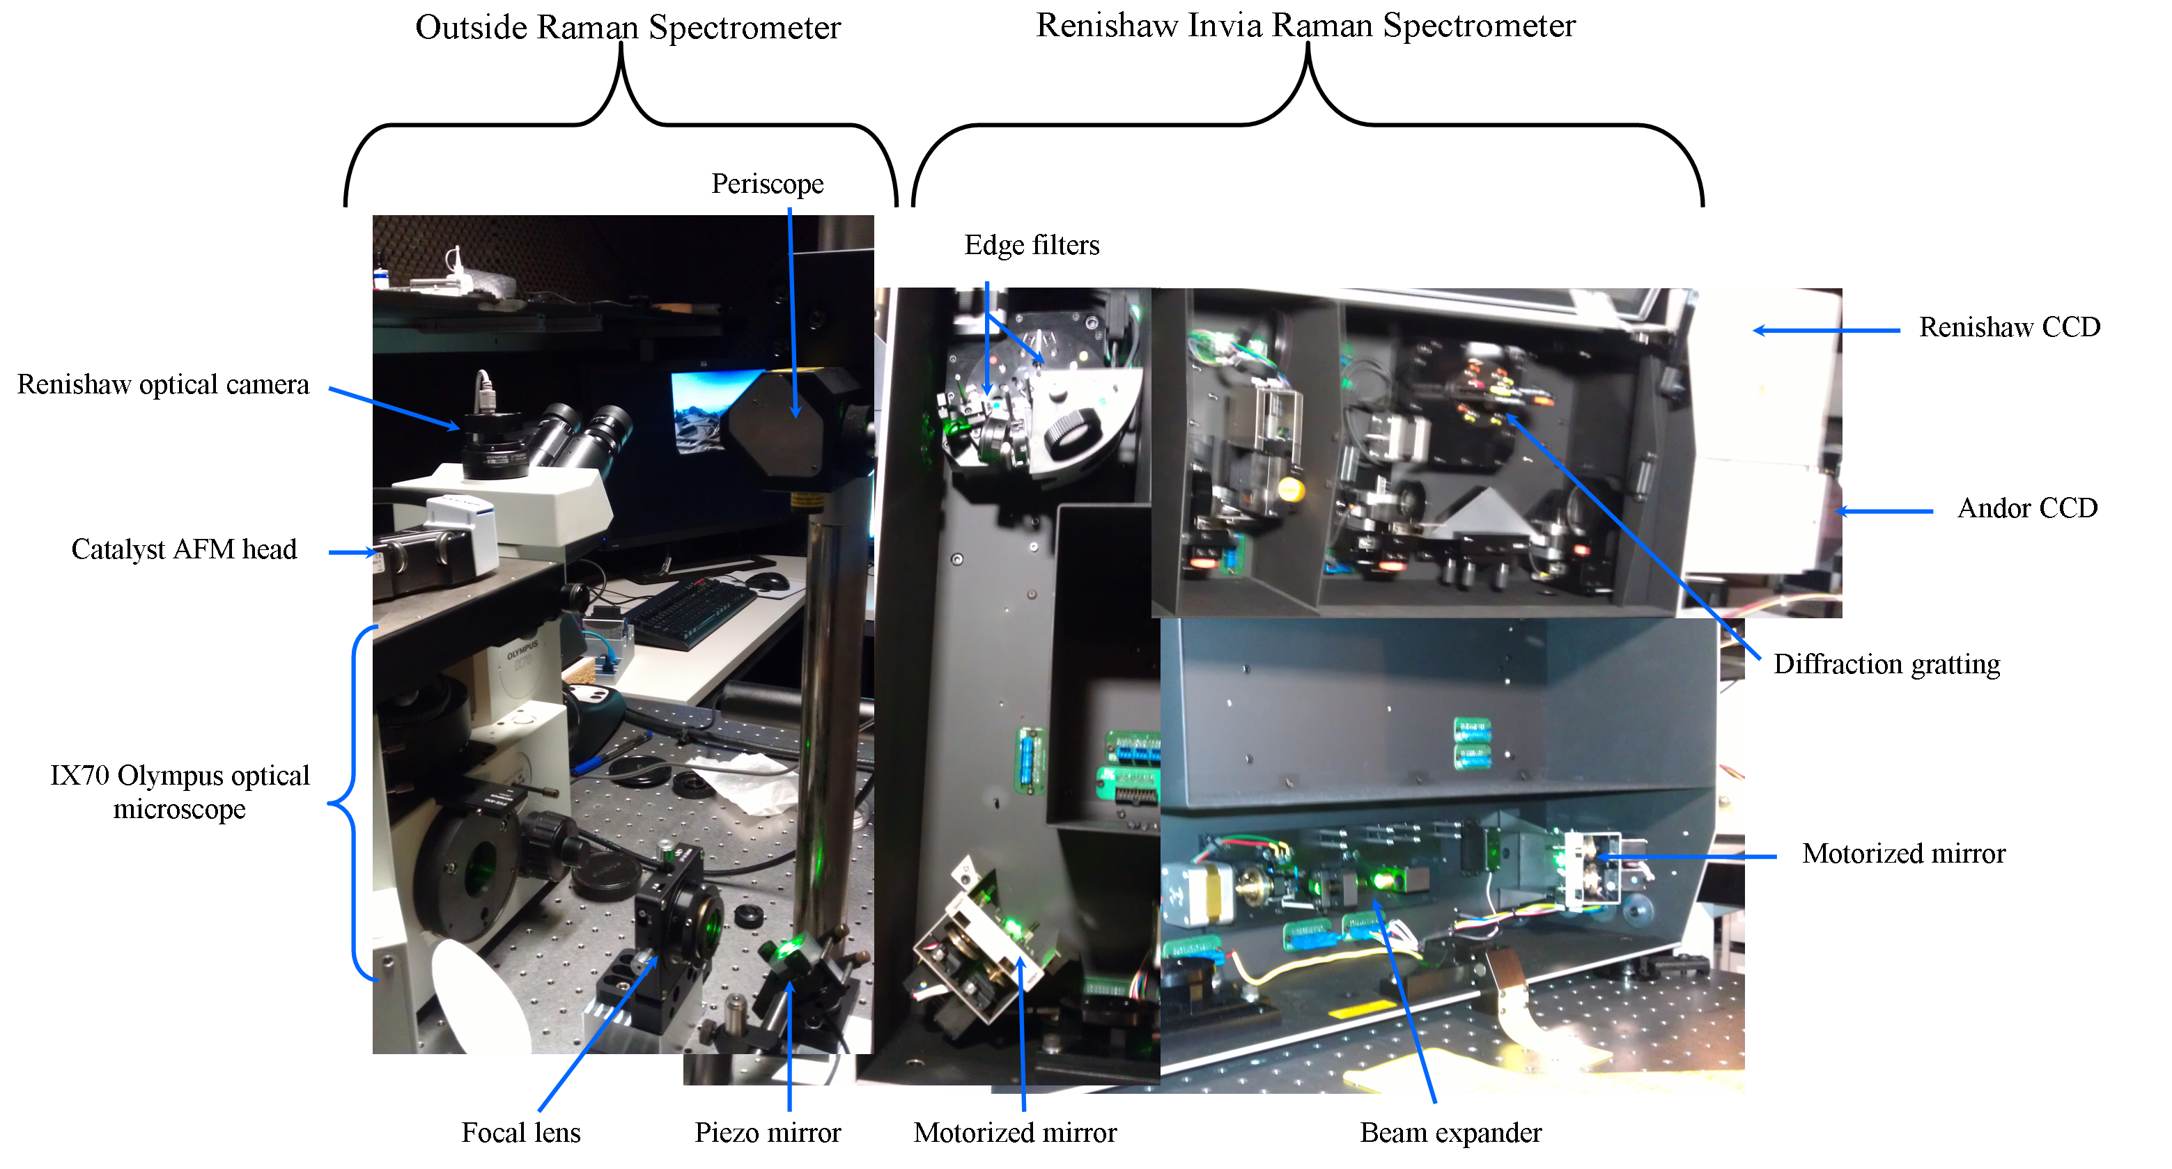
Figure 4: new AFM-TERS setup configuration.

To check the position of the red and the green lasers through the microscope objective we used blue ink on a glass coverslip (Figure 5). We also checked that the lasers were center with respect to the field of view to make sure the Raman signal originated from the part of the sample seen by the microscope. The perfect alignment of both lasers was a challenging task.
Original image | After red laser illumination | After Green laser illumination
 | 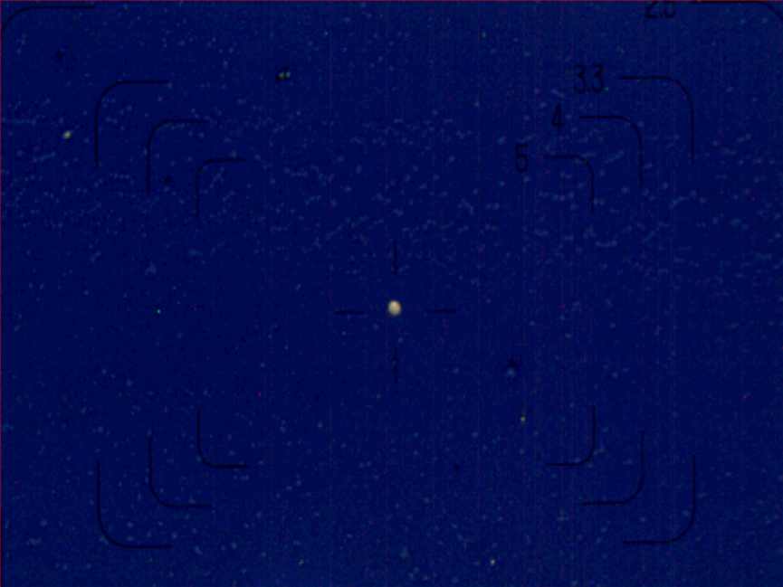 | 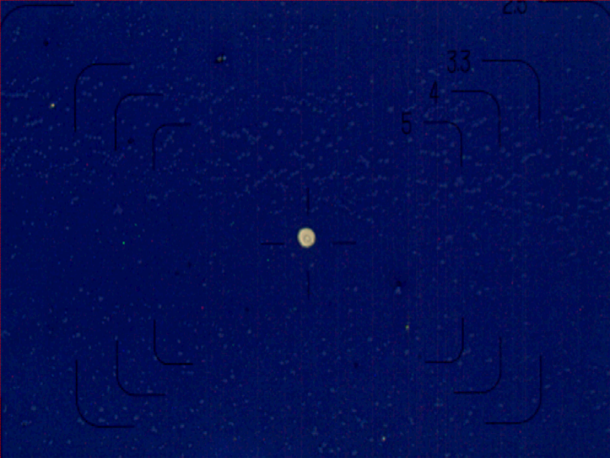
Figure 5: lasers aligned in the center of the field of view.

After laser alignment, the CCD and the microscope were aligned, using a speck of dust on a glass cover slip. Figure 6 clearly shows the speck of dust in the center of the field of view of the microscope camera and on the CCD.

Speck of dust as seen with the microscope camera | Speck of dust as seen with the CCD camera using the edge filter for red illumination | Speck of dust as seen with the CCD camera using the edge filter for green illumination
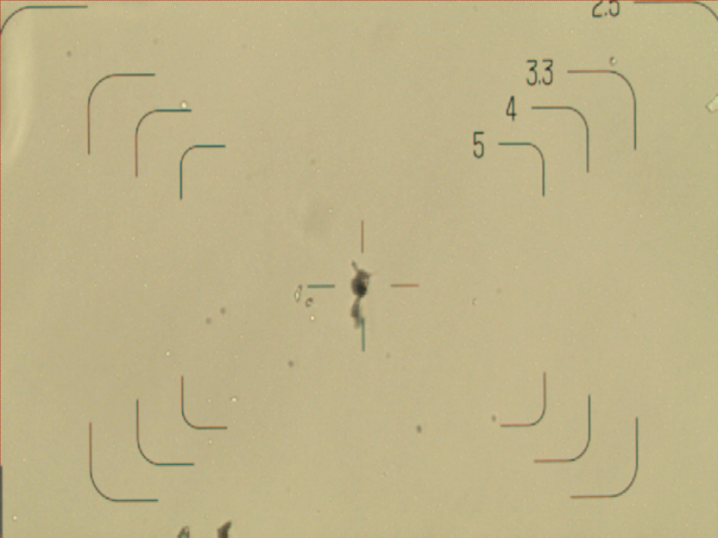 | 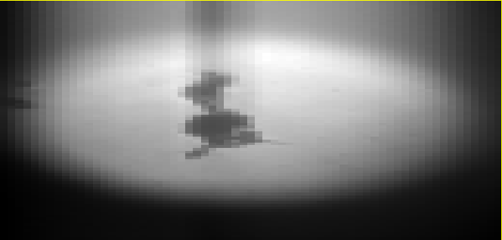
Figure 6: alignement of Renishaw CCD

To do first AFM-TERS measurements we still need to write a Labview software to control the piezo mirror (Figure 4). This mirror will serve to scan the tip with the laser to find the part of the tip with the best enhancement. Also the alignment of the Andor camera needs to be refined. Problems with the cooling system inhibited these experiments during my stay.

During these two months I also was involved in the organization of the TERS III meeting (www.tersiii.ethz.ch), which took place at ETH Zurich on August 19th and 20th. Participating in this meeting was very interesting for me: I had the opportunity to hear many talks on TERS and meet many of the actors in the field. Through this COST Action I have acquired a clear understanding of the problems emerging in AFM-TERS experiments, particularly for operation AFM-TERS in liquid. I further have acquired a clear understanding of the operating principles and physics of AFM-TERS.

References:
1. Jeanmaire, D. L.; Van Duyne, R. P., Surface raman spectroelectrochemistry: Part I. Heterocyclic, aromatic, and aliphatic amines adsorbed on the anodized silver electrode. Journal of Electroanalytical Chemistry and Interfacial Electrochemistry 1977, 84, (1), 1-20.

2. Zhang, R.; Zhang, Y.; Dong, Z. C.; Jiang, S.; Zhang, C.; Chen, L. G.; Zhang, L.; Liao, Y.; Aizpurua, J.; Luo, Y.; Yang, J. L.; Hou, J. G., Chemical mapping of a single molecule by plasmon-enhanced Raman scattering. Nature 2013, 498, (7452), 82-86.

